Vision-Based Indoor Positioning System (IPS)
AprilTag Fiducial Tracking, Homography Mapping, and State Estimation
Technical System Design Document
Document Type: Software / Algorithm Architecture Description
Scope: Sensing, Calibration, Detection, Filtering, and Pose Output Pipeline (Framework-Agnostic)
Reference Implementation: ips_node.py

Table of Contents
1. Purpose and Scope.........................................................................................................................................3
2. Design Rationale: Why This Approach Was Chosen.......................................................................................3
3. System Overview............................................................................................................................................5
4. System Architecture.......................................................................................................................................6
5. Hardware Architecture..................................................................................................................................9
6. Calibration Model..........................................................................................................................................9
7. Image Acquisition and Preprocessing...........................................................................................................11
8. Fiducial Detection.........................................................................................................................................11
9. Coordinate Transformation and Heading Extraction....................................................................................12
10. State Estimation and Filtering....................................................................................................................12
11. Relative Pose Computation........................................................................................................................13
12. Output Interface.........................................................................................................................................14
13. Visualization Overlay..................................................................................................................................14
14. Configuration Parameters..........................................................................................................................14
15. Robustness and Fallback Behaviour...........................................................................................................15
16. Limitations and Future Improvements......................................................................................................15
17. Detailed Walkthrough: How the System Produces a Pose........................................................................16
18. Glossary of Notation.................................................................................................................................19

1. Purpose and Scope
This document describes the internal working of a vision-based Indoor Positioning System (IPS) that determines the position and orientation (yaw) of multiple physical objects inside a bounded area, using a single overhead or fixed camera and passive fiducial markers (AprilTags). The description is intentionally framework-agnostic: although the reference implementation happens to run inside a ROS 2 node, none of the concepts below — camera calibration, homography, detection, filtering, coordinate transformation, or pose output — depend on ROS. The document explains what the system does, why each stage exists, and the exact mathematics and logic used at each step.
The system is designed for tracking a fixed origin marker plus up to five mobile target markers in a shared 2D ground-plane coordinate frame, publishing a smoothed, drift-corrected relative pose (x, y, yaw) for each target at the camera frame rate (~25 Hz).

2. Design Rationale: Why This Approach Was Chosen
Vision-based indoor positioning can be built around several different marker technologies. Before settling on passive AprilTag fiducials, an active-LED-based alternative was evaluated. This section documents that alternative, why it was not adopted, and the trade-offs that decision implies.

2.1 Alternative Considered: LED-Based Vision Positioning
The Chair of Flight Mechanics and Flight Control (LRT) at Universität der Bundeswehr München (UniBW) operates a vision-based indoor positioning system for its miniature vehicle fleet that takes a different marker approach. A single overhead Basler camera mounted well above the workspace observes four LEDs mounted on each tracked vehicle: three outer LEDs establish the vehicle's position and orientation, while a fourth, inner LED transmits that vehicle's identity by blinking at a distinguishing frequency. According to the publisher, this setup achieves mean accuracy on the order of roughly 1 cm in position and under 1 degree in orientation, and is reported to track up to twenty vehicles in real time under a tight per-cycle deadline, remaining robust to lighting changes and reflections (source: https://cpm.lrt.unibw.de/indoor-positioning-system/).
On accuracy alone, that LED-based approach is substantially better than the AprilTag-based results in Section 2.3 below. It was not rejected for lack of merit — it was ruled out for this particular deployment for three concrete, practical reasons.

2.2 Why the LED-Based Approach Was Not Adopted
- Dedicated per-object hardware: each tracked vehicle in the LED-based design needs its own active LED array (three pose LEDs plus one ID-flashing LED) with onboard power delivery and driver electronics. That is meaningfully more per-object hardware than a single passive, unpowered, printed AprilTag, which needs no wiring, no onboard driver circuitry, and no dedicated power budget at all.
- Fixed LED spacing requirement: the LED-based system's pose solution depends on the three outer LEDs sitting at known, fixed physical separations on top of each vehicle. Our platforms do not have that free real estate — the mounting area on each tracked object is already occupied by other sensors, and there simply is not enough uninterrupted, flat space left to place three LEDs at the required baseline distances.
- Mismatched compute architecture: the LED-based reference implementation is built around per-vehicle Raspberry Pi hardware (driving the LED ID beacon) paired with the overhead camera. Our platforms instead carry a Jetson Orin Nano per tracked object for their other on-board processing needs, with all camera capture, detection, filtering, and pose publication for the whole fleet consolidated on one central PC. Retrofitting the LED approach would mean redesigning our on-board compute stack around a different single-board computer purely to drive positioning LEDs — a much larger integration cost than adding one printed marker to an existing platform.
A passive AprilTag sidesteps all three constraints simultaneously: it is a single flat printed pattern, it requires no power or wiring, and it places no requirement whatsoever on the vehicle's onboard compute platform — the entire detection and estimation burden is carried by the central PC, not by anything mounted on the vehicle.

2.3 Accuracy Trade-off, in Context
Choosing AprilTags over LEDs is a deliberate trade of some positioning accuracy for hardware simplicity and compatibility with an already space- and sensor-constrained platform. Figure 3 summarizes the measured performance of the current AprilTag-based system: a mean position error of 5.61 cm (5.83 cm maximum) and a mean angular error of 2.66° (4.10° maximum), across an effective workspace of roughly 3.28 m × 3.85 m (about 12.63 m² of coverage). This is noticeably coarser than the roughly 1 cm / under-1° figures reported for the LED-based reference system, which is expected: precisely-spaced, actively-illuminated LED markers are inherently easier to localize to sub-centimetre precision than a single printed tag viewed from a wide-angle overhead camera. The gap is an accepted, known cost of a design that otherwise fits the available mounting space and the existing PC-plus-Jetson compute architecture.
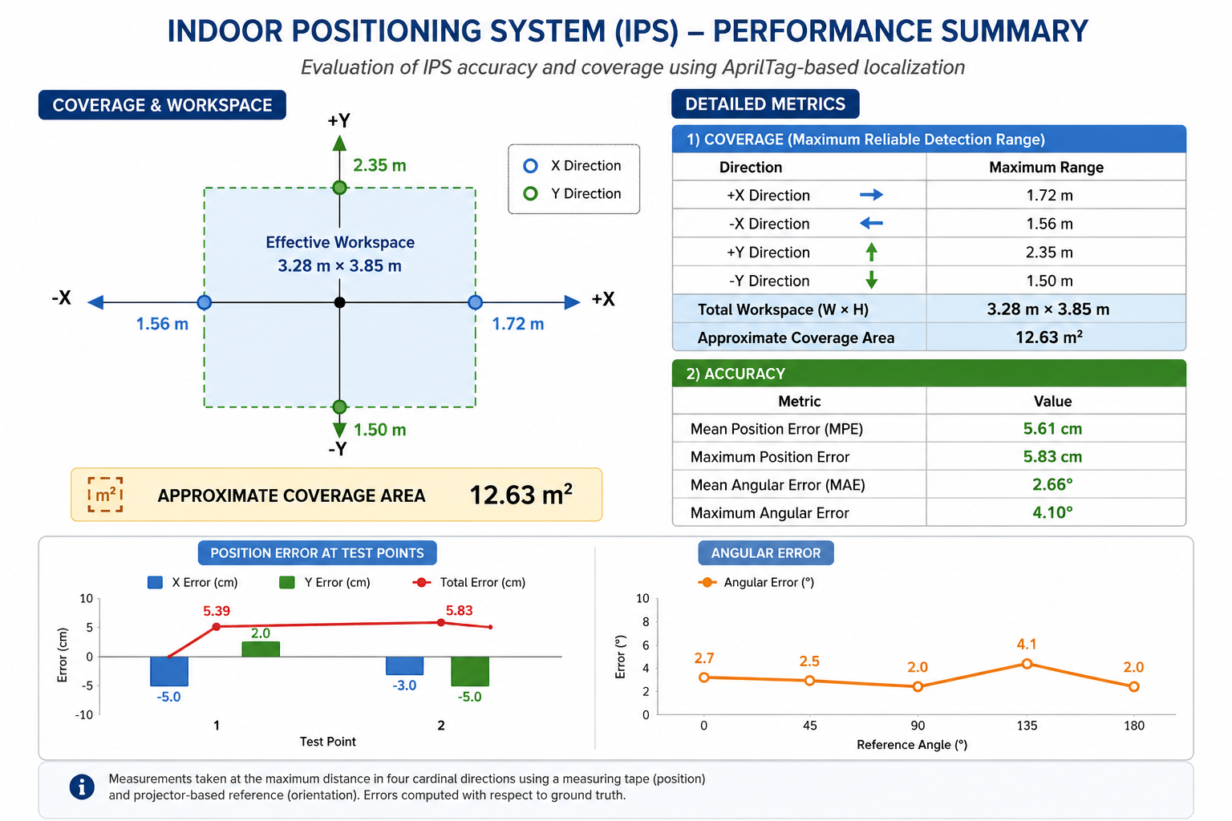
Figure 3 — Measured performance summary of the deployed AprilTag-based IPS: coverage/workspace extent (top left), detailed coverage and accuracy metrics (top right), per-test-point position error (bottom left), and angular error versus reference angle (bottom right). Position measured by tape measure against the four cardinal directions; orientation measured against a projector-based ground-truth reference.

2.4 Comparison Summary
Aspect | LED-Based Reference System (UniBW LRT) | This System (AprilTag Vision)
Marker type | Active: 3 pose LEDs + 1 ID-flashing LED per vehicle | Passive: one printed AprilTag per tracked object
Per-object hardware | LED array + driver electronics + power wiring; Raspberry Pi for ID beacon | None dedicated to positioning; existing Jetson Orin Nano untouched
Physical space needed | Fixed, known LED baseline spacing on top of each vehicle | One flat tag face; fits alongside existing sensors
Central compute | Overhead camera + processing | Single central PC (capture, detection, filtering, publishing)
Reported / measured accuracy | ~1 cm position, <1° orientation (mean, as reported) | 5.61 cm mean position error, 2.66° mean angular error (measured)
Real-time capability | Up to 20 vehicles, 20 ms soft deadline (as reported) | For now, 5 vehicles at 10 Hz per-frame processing rate
In short: the LED-based approach was set aside not because of any shortcoming in its reported accuracy, but because its hardware model — dedicated per-vehicle LED electronics at a fixed spacing, on a Raspberry Pi-based platform — does not fit a deployment where mounting space is already committed to other sensors and the on-board compute platform (Jetson Orin Nano) and central architecture (single PC) were fixed by other project constraints.

3. System Overview
At a high level, the IPS operates as a closed pipeline that repeats once per camera frame:
- Acquire an image frame from a camera source.
- Undistort and rectify the frame using pre-computed lens-calibration maps.
- Detect AprilTag fiducial markers in the corrected grayscale image.
- Refine each detected tag's centre to sub-pixel accuracy.
- Project each tag's pixel-space centre into a real-world planar coordinate using a homography matrix.
- Track each tag's world position through a Kalman filter to reduce measurement noise and bridge brief detection gaps.
- Estimate each target tag's heading (yaw) from its corner geometry and smooth it using a delta-based sliding-window mean.
- Compute each target's pose relative to a designated origin tag, and apply a small jitter-damping smoother.
- Package the result into a standard pose message (position + quaternion) and publish/output it, alongside an optional annotated visualization.
Figure 1 illustrates this pipeline and the data that flows between its stages.
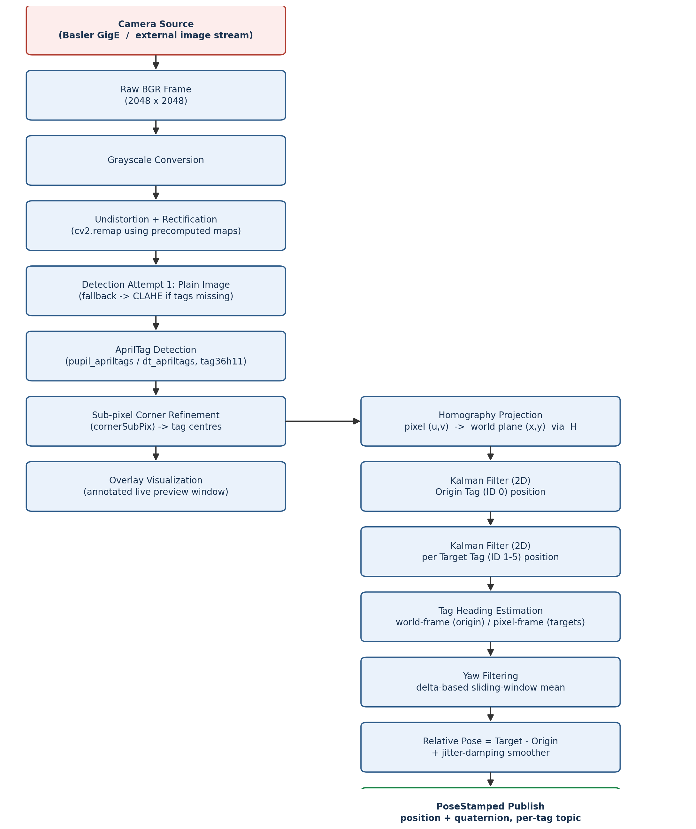
Figure 1 — End-to-end data-flow architecture of the IPS pipeline. Column A (left) is the acquisition/detection stage; Column B (right) is the geometric-mapping, filtering, and output stage. All connectors run strictly vertically or horizontally, so no line crosses through an unrelated box.

4. System Architecture
Section 3 showed the per-frame data flow — what happens to one image as it passes through the pipeline. This section instead describes the system's static architecture: the structural components the software is built from, the responsibility each one owns, how they depend on one another, and the boundaries between them. These are two complementary views of the same system, not two different systems.

4.1 Architectural Style
The system is a single-process, layered pipeline architecture, not a distributed or multi-node system: one component owns image acquisition, hands a frame to the next layer, and so on down to publishing. Concurrency is limited to the fiducial detector's internal multi-threaded decode step; everything else in a given frame's pass executes sequentially and synchronously before the next frame begins. This keeps the system's behaviour easy to reason about (one frame in, one pose set out, no partially-overlapping frame processing) at the cost of the whole pipeline being only as fast as its slowest stage.

4.2 Layered View
The components group naturally into four processing layers plus two cross-cutting concerns (calibration/configuration, and visualization), shown in Figure 2:
- Sensing Layer — owns the physical or logical camera connection and produces raw BGR frames. Two interchangeable implementations exist behind this same role: a direct industrial-camera driver, or an adapter that reads frames handed to it by an external process.
- Perception Layer — turns a raw frame into geometric measurements: preprocessing (grayscale, undistortion, adaptive contrast fallback), fiducial detection, sub-pixel corner refinement, and homography projection into world coordinates.
- Estimation Layer — turns noisy, frame-local measurements into smoothed, temporally-consistent per-tag state: one Kalman filter instance per tracked tag for position, and one sliding-window yaw filter instance per target tag.
- Output Layer — turns per-tag filtered state into the externally-visible result: computing the relative pose against the origin tag, applying the jitter-damping smoother, packing the result into a position + quaternion pose, and publishing it.
- Calibration & Configuration (cross-cutting) — the homography matrix, camera intrinsics/distortion, and all tunable runtime parameters are owned by one dedicated loading step and injected into whichever layer needs them, rather than being hard-coded inside those layers. This is what makes the Sensing/Perception/Estimation layers re-usable across different physical camera rigs without code changes.
- Visualization (cross-cutting) — a consumer, not a participant, in the main pipeline: it reads whatever Perception and Estimation have already produced for the current frame purely to render a preview, and never feeds anything back into the pipeline. Disabling it has zero effect on published poses.
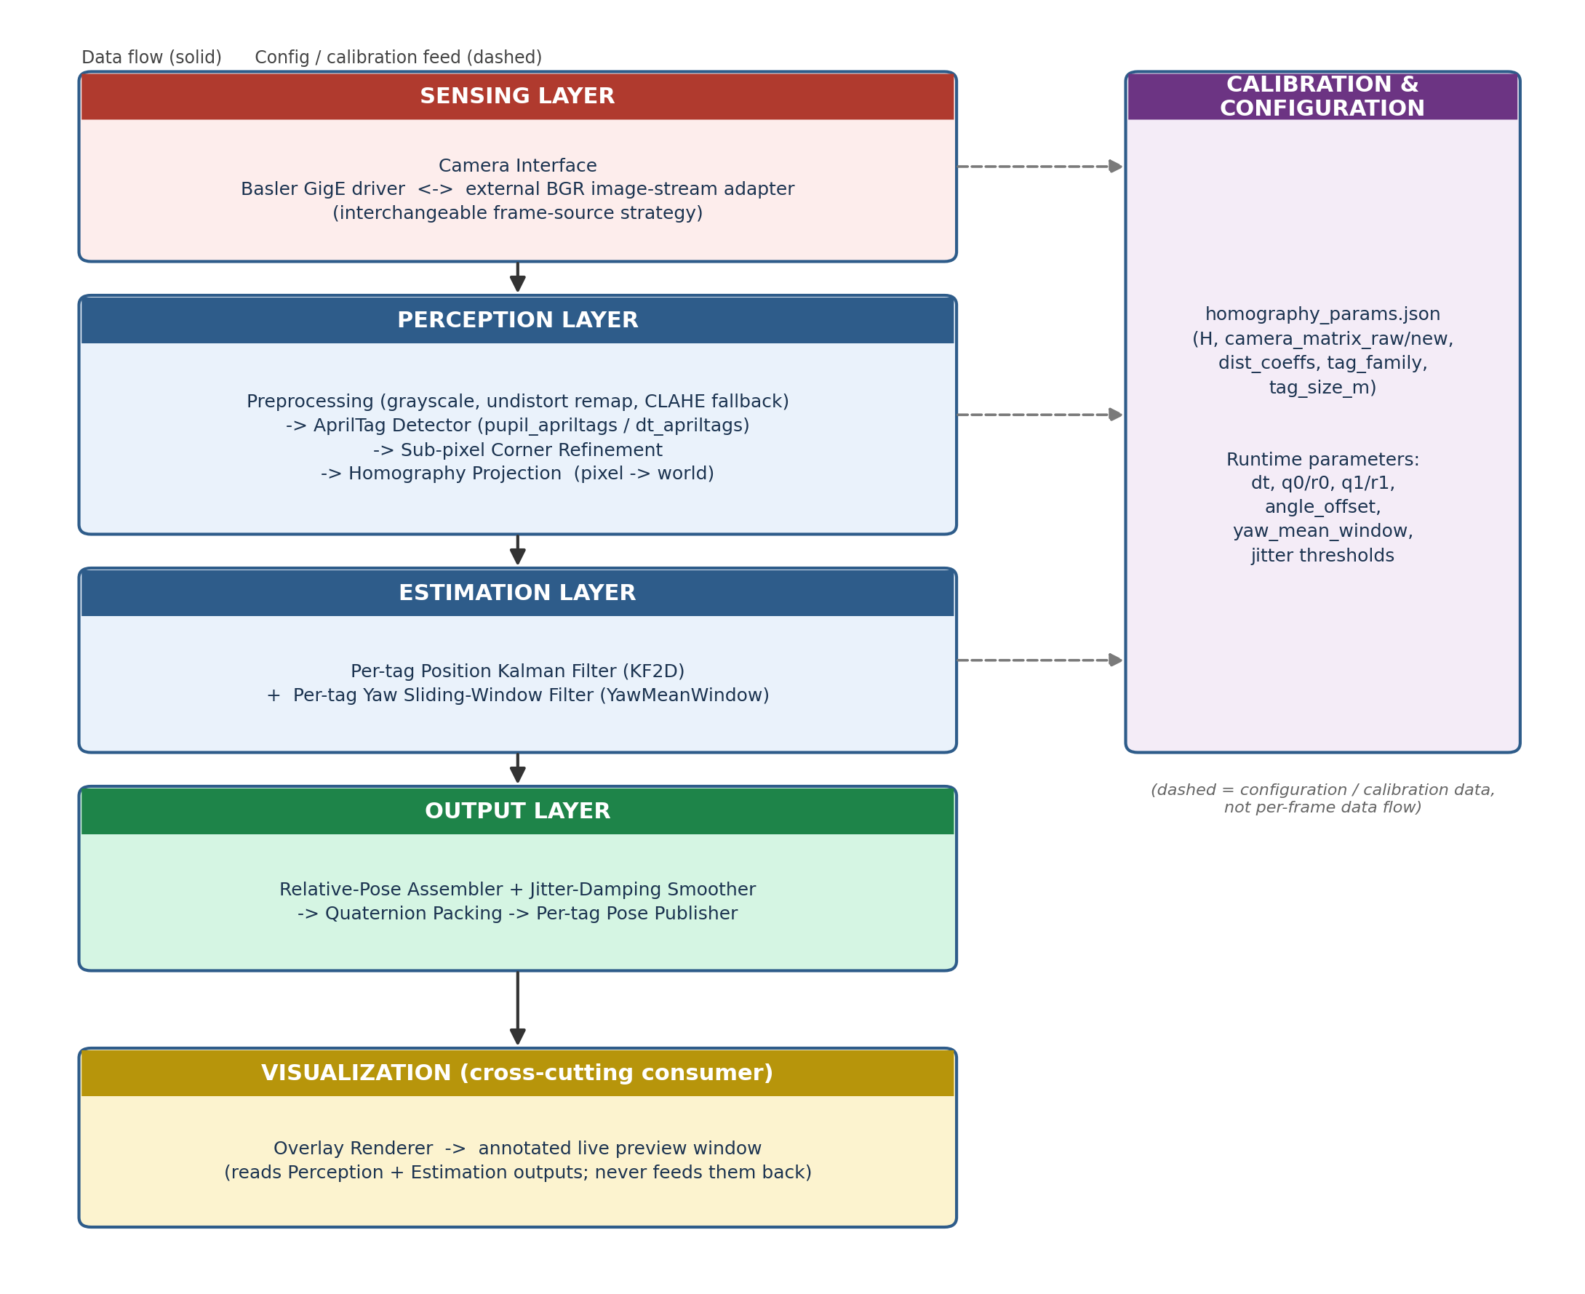
Figure 2 — Layered system architecture. Solid arrows are per-frame data flow between layers; dashed arrows are one-time or occasional configuration/calibration feeds, not part of the per-frame path.

4.3 Component Responsibilities
Component | Responsibility | Key Functions / Classes
Camera Interface | Abstracts the frame source; delivers one BGR frame per invocation regardless of underlying hardware. | Basler grab callback; external image-stream adapter
Calibration Loader | Reads the homography matrix, camera intrinsics, distortion coefficients, and tag metadata once at start-up. | load_params()
Preprocessing | Converts to grayscale, applies the pre-computed undistortion map, and runs the CLAHE fallback pass when needed. | cv2.remap, CLAHE, detect()
Fiducial Detector | Wraps the underlying AprilTag library and normalizes its output regardless of which backend is installed. | build_detector(), _run()
Geometry Module | Pure-math routines: sub-pixel centres, pixel <-> world projection, heading extraction. | refined_centre(), px_to_world(), tag_heading_rad(), tag_heading_pixel_rad()
Position Estimator | One instance per tracked tag; maintains a constant-velocity Kalman state across frames. | KF2D
Yaw Estimator | One instance per target tag; maintains a rolling buffer of recent yaw samples. | YawMeanWindow (YawLPF available, currently unused)
Pose Assembler | Subtracts origin from target, applies jitter-damping, and builds the final message. | logic inside the per-frame processing routine
Publisher | Exposes one output channel per target tag ID to any downstream consumer. | per-tag publisher objects
Visualization | Optional annotated preview; entirely decoupled from the publishing path. | _draw_overlay()
Orchestrator | Owns start-up wiring (reads config, builds all of the above, chooses the camera source) and the per-frame callback that drives them in sequence. | top-level node class

4.4 Interfaces and Boundaries
- Input boundary: exactly one interface — "give me the next BGR frame" — with two interchangeable providers behind it. Nothing downstream depends on which provider is active.
- Configuration boundary: every tunable value (calibration file path, filter noise terms, angle offset, yaw window length, display options) enters through one parameter-declaration surface at start-up, rather than being embedded inside the layers that use it.
- Output boundary: three independent surfaces consume the pipeline's results — the per-tag pose channels (the primary, machine-readable interface), a human-readable log line per tag per frame, and the optional visualization window. A consumer of one has no dependency on, or effect on, the others.

4.5 Statefulness
Most of the pipeline is stateless and frame-local: preprocessing, detection, sub-pixel refinement, and homography projection all take this frame's data and produce this frame's output with no memory of previous frames. Statefulness is concentrated in exactly three places, all inside the Estimation and Output layers, and all keyed per tag ID: each tag's Kalman filter (position + velocity estimate and covariance), each target tag's yaw sample buffer, and each target tag's previous smoothed (x, y) used by the jitter-damping step. This concentration of state is deliberate — it means the Perception layer and Sensing layer can be reasoned about, tested, or replaced independently, without touching how tracking continuity is maintained.

5. Hardware Architecture

5.1 Camera Subsystem
The system supports two interchangeable image sources, selected by a configuration flag:
- Industrial GigE camera (Basler, via pypylon): operated at a fixed 2048×2048 resolution with a configurable exposure time (default 10,000 µs). Frames are pulled on a fixed internal timer (10 Hz, 0.1 s period) using a "latest image only" grab strategy so the pipeline always processes the most recent frame rather than queuing stale ones.
- Generic image-topic source: any external process that publishes BGR8 image frames on a subscribed channel. This path is used when a pre-existing camera driver / capture process is already feeding frames into the system rather than the software owning the camera directly.
Both sources converge on the same downstream processing function, so the rest of the pipeline is completely independent of which camera path is active.

5.2 Fiducial Markers
The system uses AprilTag markers from the tag36h11 family (configurable). Six tag identities are defined:
- Tag ID 0 — the Origin Tag: a fixed reference marker whose world position and heading define the coordinate frame that all other tags are measured against.
- Tag IDs 1–5 — Target Tags: the mobile objects being tracked.
Each tag physically encodes its ID in a black-and-white pattern; the detector library extracts the four corner pixel coordinates of each tag it can find in the image.

6. Calibration Model
Before the pipeline can convert pixel measurements into real-world metric coordinates, the camera must be calibrated. Calibration results are pre-computed offline and loaded from a JSON configuration file at start-up. The file contains:
Field | Meaning
homography_matrix | 3×3 matrix H mapping undistorted pixel coordinates to world-plane coordinates (metres).
camera_matrix_new | 3×3 intrinsic matrix after distortion-optimal rectification (used as the target intrinsics for undistortion).
camera_matrix_raw | 3×3 intrinsic matrix of the raw, uncorrected camera.
dist_coeffs | Lens distortion coefficients (radial + tangential).
tag_family | AprilTag dictionary/family in use (default tag36h11).
tag_size_m | Physical edge length of a tag, in metres (default 0.10 m) — used for reference/scale.

6.1 Lens Undistortion and Rectification
At start-up the raw and rectified intrinsic matrices and distortion coefficients are used to pre-compute a fixed pixel-remapping table for the full 2048×2048 sensor resolution (via an undistort-rectify map generator). Every incoming frame is then corrected with a single, cheap remap operation instead of repeating the full undistortion calculation per frame, which keeps the pipeline running at full camera frame rate.

6.2 Planar Homography — Pixel-to-World Mapping
Because all tags lie on (or very near) a single physical plane — e.g. a floor, table, or wall — a 3×3 homography matrix H is sufficient to map any undistorted pixel coordinate to a real-world 2D coordinate on that plane, without needing full 3D pose estimation. The mapping uses homogeneous coordinates:
given pixel point p = (u, v)
build homogeneous vector p_h = [u, v, 1]^T
project: w_h = H · p_h
normalize: (x, y) = (w_h[0] / w_h[2], w_h[1] / w_h[2])
H itself is computed once, offline, during a calibration procedure (not part of the runtime pipeline) that observes known reference points and solves for the matrix that best maps their pixel locations to their true metric locations. At runtime the pipeline only consumes the pre-solved matrix.

6.2.1 Note: This Is Not Triangulation
It is worth being explicit that this system does not use triangulation. Triangulation recovers a 3D point by intersecting two or more independent viewing rays (e.g. two cameras, or a moving camera with known baseline); this system uses only a single, fixed camera, so no second ray is ever available to intersect. A single camera view is normally ambiguous — any given pixel corresponds to an entire ray through space, not a unique point — and that ambiguity is resolved here not by triangulating, but by exploiting the fact that every tag is constrained to lie on one known physical plane. Given that planarity constraint, a single ray intersecting a single known plane yields exactly one 3D point, which is precisely what the homography matrix encodes and applies. This technique is sometimes called Inverse Perspective Mapping. Note also that the AprilTag detector libraries used here are capable of full monocular 6-DOF pose estimation via Perspective-n-Point (PnP), using each tag's known physical size — a different single-view technique from either triangulation or homography — but that mode is explicitly disabled in this pipeline in favour of the simpler, planar homography approach, since only 2D ground-plane position and yaw are required.

7. Image Acquisition and Preprocessing

7.1 Frame Retrieval
Each new frame — regardless of source — triggers the same processing routine. A running frames-per-second estimate is maintained using an exponential average of inter-frame timing, primarily for on-screen diagnostics.

7.2 Grayscale Conversion and Undistortion
Colour frames are converted to grayscale (fiducial detection does not require colour). The grayscale image is then passed through the pre-computed remap table from Section 6.1 to produce a geometrically corrected image in which straight lines in the physical world appear straight in the image — a prerequisite for accurate homography-based projection.

7.3 Adaptive Contrast Enhancement (CLAHE) Fallback
Detection is attempted first on the plain rectified grayscale image. If not all expected tag IDs (origin + all targets) have been found yet, a second pass is run on a locally contrast-enhanced version of the same image, produced by Contrast-Limited Adaptive Histogram Equalization (CLAHE, clip limit 3.0, 8×8 tile grid). Detections are merged by tag ID, with the first pass taking priority; the CLAHE pass only fills in tags that were missed under plain lighting conditions (e.g. glare, shadow, or low contrast on a specific tag). This two-pass merge strategy improves detection robustness without paying the CLAHE cost when it isn't needed.

8. Fiducial Detection

8.1 Detector Backend
The system uses one of two interchangeable AprilTag detector libraries, chosen automatically based on what is installed in the runtime environment: a primary multi-threaded detector, or a fallback detector with an equivalent interface. Both are configured with 4 detection threads, no quad decimation (full-resolution search for maximum accuracy), and — for the primary backend — sub-pixel edge refinement with mild decode sharpening. Pose estimation inside the detector library itself is disabled, because the system computes its own, more application-specific pixel-to-world mapping via the homography instead.

8.2 Sub-pixel Corner Refinement
The detector library returns integer/float corner estimates for each tag's four corners. To reduce quantization noise, the pipeline re-refines these corners using a classic corner sub-pixel optimization (5×5 search window, iterative refinement to 0.001 px or 15 iterations), then computes the tag centre as the mean of the four refined corners. This meaningfully reduces frame-to-frame jitter before any filtering is even applied.

9. Coordinate Transformation and Heading Extraction

9.1 Pixel-to-World Projection
Each tag's refined centre pixel is projected into world coordinates using the homography formula from Section 6.2, producing a raw (unfiltered) world-frame (x, y) measurement in metres for every tag detected in the current frame.

9.2 Heading (Yaw) from Tag Geometry
A tag's four corners are ordered consistently by the detector, which lets the pipeline reconstruct the tag's "forward" direction directly from corner geometry rather than from a full pose solve. Two variants of this computation exist:
- World-frame heading: each corner is first projected into world coordinates via the homography, then the two "top" edge vectors are averaged to form a forward vector, and the heading is the angle of that vector. This is used only for the origin tag.
- Pixel-frame heading: the same forward-vector construction is applied directly in pixel space, without homography projection. This is used for all target tags, since it is cheaper and, given a locally near-planar homography, sufficiently accurate for orientation.
Both variants add a configurable angle-offset correction (in degrees) to compensate for any constant mechanical or mounting misalignment between a tag's printed orientation and its physical reference direction.
left_edge = corner[3] - corner[0]
right_edge = corner[2] - corner[1]
forward = left_edge + right_edge
heading = atan2(-forward.y, forward.x) + angle_offset

10. State Estimation and Filtering
Raw per-frame measurements are noisy (pixel quantization, lighting flicker, marker occlusion) and are therefore never used directly as the output. Two independent filtering subsystems are applied: one for position, one for yaw.

10.1 Position: Constant-Velocity Kalman Filter
Each tracked tag (the origin, and each of the five targets independently) has its own 2D Kalman filter with a 4-element state vector [x, y, vx, vy] and a 2-element measurement vector [x, y]. The state transition assumes constant velocity over the sample interval dt:
state: [x, y, vx, vy]
transition: x' = x + vx·dt
y' = y + vy·dt
vx' = vx
vy' = vy
measurement: z = [x, y] (from homography projection)
Process noise covariance (q) and measurement noise covariance (r) are independently tunable for the origin tag versus the target tags, since the origin tag is typically static (favoring a smaller q, more trust in the motion model) while target tags may move (a separate q1/r1 pair).

10.2 Predict-Only Fallback
If a tag is briefly occluded or fails to decode in a given frame, its Kalman filter is not updated with a new measurement; instead, the filter's predict step alone is used to extrapolate its position for that frame, based purely on its last known velocity estimate. This bridges short detection gaps smoothly instead of freezing or discarding the tag's pose outright. A tag that has never been detected at all (filter never initialized) is simply omitted from that frame's output.

10.3 Yaw Filtering — Delta-Based Sliding-Window Mean
Yaw angles cannot be averaged naively because they wrap at ±180°. The active filter (a windowed mean, default window length 10 samples) avoids this problem by always referencing the most recent sample: it computes the wrapped angular difference of every buffered sample relative to the newest one, averages those small deltas (which never cross the wrap boundary because they are all measured relative to a common, current reference), and adds the resulting mean-delta back onto the reference angle. The final result is re-wrapped into (−180°, 180°].
buffer = last N raw yaw samples (radians), newest last
ref = buffer[-1]
for each sample v in buffer:
delta = wrap_to_(-pi, pi]( v - ref )
mean_delta = average(all deltas)
yaw_filtered = wrap_to_(-pi, pi]( ref + mean_delta )
The filter only updates on frames where the target tag was actually detected — a missed detection simply leaves the previous filtered yaw value in place rather than injecting a stale or zero value. Note: the codebase also defines an exponential-moving-average (EMA) circular yaw low-pass filter as an alternative smoothing strategy (accumulating on the sin/cos unit-circle components to avoid wrap-around error), but in the current configuration only the sliding-window mean filter above is active; the EMA filter is retained as an available, drop-in alternative.

11. Relative Pose Computation

11.1 Origin-Relative Coordinate Frame
All target positions are expressed relative to the filtered origin-tag position, not in absolute homography-plane coordinates. This makes the output robust to any fixed offset error in the homography calibration and gives a physically meaningful frame: "metres from the origin tag," with the origin tag's own heading available separately as a world reference direction.
relative_position = filtered_target_position - filtered_origin_position

11.2 Jitter-Damping Position Smoother
As a final smoothing stage, each target's relative (x, y) is compared against its own previous output. If the frame-to-frame movement is small (≤ 0.2 m — consistent with sensor noise rather than genuine motion), the output is pulled only halfway toward the new value (a simple exponential damping with factor 0.5), suppressing residual micro-jitter. If the movement exceeds that threshold, it is treated as real motion and the new value is passed straight through, so the system stays responsive to genuine, fast movement instead of over-smoothing it.

12. Output Interface

12.1 Pose Message Content
For every target tag with a valid relative position for the current frame, a timestamped pose is produced containing:
- Position: (x, y) in metres relative to the origin tag, z fixed at 0 (planar tracking).
- Orientation: the filtered yaw angle converted to a quaternion (roll = 0, pitch = 0, yaw = filtered angle), since the system tracks 2D planar pose only.

12.2 Publication Channel
Each target tag is published on its own dedicated output channel (one per tag ID), so downstream consumers can subscribe to only the tags they care about. A human-readable log line is also emitted per tag per frame, reporting relative X/Y, filtered yaw in degrees, and the corresponding raw (unfiltered) yaw for comparison/debugging.

13. Visualization Overlay
An optional live preview window (disable-able via configuration, and automatically disabled if no display is available in the runtime environment) draws:
- Coloured outlines around every detected tag (origin tag in green, each target tag in a distinct fixed colour), plus its refined sub-pixel centre.
- A line from the origin tag to each visible target tag, labeled with that target's relative X, Y, and filtered yaw.
- A running FPS and frame-counter readout.
The preview frame is generated from the undistorted colour image (or a grayscale-to-colour conversion if no colour frame is available) and displayed at a configurable downscale factor to keep rendering lightweight.

14. Configuration Parameters
The following parameters control runtime behaviour without requiring code changes:
Parameter | Default | Purpose
params_file | config/homography_params.json | Path to the calibration file described in Section 6.
camera_topic | /camera/image_raw | External image channel used when not reading directly from a Basler camera.
use_basler | true | Selects direct Basler GigE capture vs. an externally supplied image stream.
angle_offset | 0.0° | Constant heading correction applied to all tag angle computations.
dt | 0.1 s | Kalman filter sample interval (matches ~10 Hz capture rate).
q0 / r0 | 1e-5 / 1e-4 | Process / measurement noise for the origin-tag Kalman filter.
q1 / r1 | 5e-4 / 1e-4 | Process / measurement noise for each target-tag Kalman filter.
yaw_mean_window | 10 samples | Window length for the delta-based sliding-window yaw mean filter.
display_scale | 0.5 | Downscale factor applied to the visualization preview window.
show_display | true | Enables/disables the live preview window.

15. Robustness and Fallback Behaviour
- Missing target tag: predict-only Kalman extrapolation (Section 10.2) keeps a brief, smooth estimate rather than dropping the tag output abruptly.
- Missing origin tag: no relative poses are published for that frame at all, since without the origin no valid relative frame exists; the pipeline resumes automatically once the origin tag reappears.
- Detector library unavailable: the system fails fast at start-up with a clear installation instruction rather than running in a degraded/undefined detection mode.
- Required camera-interface library unavailable: the corresponding capture path raises an explicit error at start-up rather than silently doing nothing.
- No display environment available: the visualization step is automatically disabled after the first failure, and the rest of the pipeline (detection, filtering, publishing) continues unaffected.

16. Limitations and Future Improvements
- The homography model assumes all tags lie on a single plane; tags mounted at meaningfully different heights than the calibration plane will project with a systematic error proportional to their height offset.
- Yaw for target tags is currently derived from pixel-space geometry rather than the world-projected (homography-corrected) geometry used for the origin tag; this is a reasonable approximation only for a roughly fronto-parallel camera view.
- The jitter-damping position smoother uses a fixed 0.2 m threshold and 0.5 damping factor; adaptive thresholds tied to measured Kalman uncertainty would generalize better across different marker sizes and camera distances.
- The EMA circular yaw filter is implemented but currently inactive; combining it with the sliding-window mean (LPF first, then windowed mean) is available as a future tuning option if additional smoothing is desired.
- Detection currently supports up to six fixed tag identities (one origin + five targets); scaling to a larger, dynamic set of tracked tags would require generalizing the fixed ID lists into a runtime-configurable set.

17. Detailed Walkthrough: How the System Produces a Pose
The preceding sections describe each stage of the pipeline separately. This section threads all of them together into a single, concrete, worked example — following one target tag through two consecutive frames, with actual numbers at every stage — so it is unambiguous exactly how a final (x, y, yaw) pose is derived from a raw camera image. The homography, corner, and noise values below are illustrative (chosen to make the arithmetic easy to follow), not the real calibration file contents, but every formula and every piece of logic is exactly what the code executes.

17.1 Setup
- Origin Tag = ID 0. Target Tag = ID 3.
- Illustrative homography matrix H (maps undistorted pixel coordinates to world-plane metres):
H = | 0.001 0 0.0 |
| 0 -0.001 2.0 |
| 0 0 1 |
i.e. x = 0.001 * u
y = 2.0 - 0.001 * v
- Kalman filters: dt = 0.04 s. Origin filter uses (q0, r0); Target filter uses (q1, r1) — target trusts new measurements a bit more, since it is expected to move.
- Yaw filter: sliding-window mean, window = 10 (only 1–2 samples shown here for clarity).
- Jitter-damping smoother threshold = 0.2 m, damping factor = 0.5.

17.2 Frame 1 — Cold Start
Step 1 — Detection and sub-pixel refinement. The detector returns four corners per tag; cornerSubPix refines them. Suppose the refined corners are:
Origin Tag (ID 0) corners: (300,300) (340,300) (340,340) (300,340)
-> centre (mean of 4 corners) = (320.0, 320.0) px
Target Tag (ID 3) corners: c0=(900,500) c1=(946,494) c2=(966,488) c3=(920,495)
-> centre (mean of 4 corners) = (933.0, 494.25) px
Step 2 — Homography projection (pixel -> world), applied independently to each tag's centre:
Origin: x = 0.001*320.0 = 0.320 m y = 2.0 - 0.001*320.0 = 1.680 m
-> raw_world[0] = (0.320, 1.680)
Target: x = 0.001*933.0 = 0.933 m y = 2.0 - 0.001*494.25 = 1.506 m
-> raw_world[3] = (0.933, 1.506)
Step 3 — Kalman filter (position). Since this is the first frame, each filter has no prior state, so it initializes directly to the measurement (statePost = [x, y, 0, 0]) and its corrected output equals the raw measurement exactly:
kf0.update((0.320, 1.680)) -> w0 = (0.320, 1.680)
kf_targets[3].update((0.933, 1.506)) -> w3 = (0.933, 1.506)
Step 4 — Heading (yaw) from tag-3 corner geometry, computed directly in pixel space:
left_up = c3 - c0 = (920-900, 495-500) = (20, -5)
right_up = c2 - c1 = (966-946, 488-494) = (20, -6)
forward = left_up + right_up = (40, -11)
heading = atan2(-(-11), 40) = atan2(11, 40) = 0.2705 rad = 15.5 deg
(+ angle_offset, here 0.0 deg)
Step 5 — Yaw filter (sliding-window mean). With only one sample buffered, the reference equals that sample and the mean delta is zero, so the filtered yaw equals the raw yaw:
buffer = [15.5 deg] ref = 15.5 deg mean_delta = 0.0 deg
yaw_filtered = 15.5 deg (0.2705 rad)
Step 6 — Relative pose (target minus origin):
rel = w3 - w0 = (0.933 - 0.320, 1.506 - 1.680) = (0.613, -0.174) m
Step 7 — Jitter-damping smoother. prev_x/prev_y start at (0.0, 0.0) for every tag. Frame-to-frame movement is measured against that previous output:
movement = hypot(0.613 - 0.0, -0.174 - 0.0) = 0.637 m (> 0.2 m threshold)
-> treated as real motion: pass value straight through
prev_x[3], prev_y[3] = 0.613, -0.174
Step 8 — Quaternion conversion and publish. With yaw_z = 0.2705 rad (roll = pitch = 0):
qx = 0, qy = 0, qz = sin(yaw_z/2) = 0.1349, qw = cos(yaw_z/2) = 0.9909
PoseStamped (topic /apriltag/tag3/pose, frame_id 'tag0_origin')
position: x=0.613 y=-0.174 z=0.0
orientation: x=0.0 y=0.0 z=0.1349 w=0.9909

17.3 Frame 2 — Steady-State Tracking (0.04 s later)
Now suppose the tag has moved slightly and pixel-level noise is present. The detector returns a new centre for tag 3 corresponding to raw_world[3] = (0.939, 1.500); the origin tag is assumed static and its filtered position remains w0 = (0.320, 1.680).
Step 1 — Kalman predict + correct. The filter first predicts forward using its last velocity estimate, then blends that prediction with the new measurement, weighted by the relative process/measurement noise (q1, r1). Unlike Frame 1, the output is now a blend rather than a bare passthrough of the measurement:
predict: x' = 0.933 + vx*dt (~0.933), y' = 1.506 + vy*dt (~1.506)
correct with z=(0.939, 1.500):
w3_filtered ~= (0.937, 1.502) <- pulled toward the new measurement,
but not equal to it (noise partially rejected)
Step 2 — Relative pose:
rel = (0.937 - 0.320, 1.502 - 1.680) = (0.617, -0.178) m
Step 3 — Jitter-damping smoother. This time the change from the previous published output (0.613, -0.174) is small:
movement = hypot(0.617-0.613, -0.178-(-0.174)) = 0.0057 m (<= 0.2 m threshold)
-> treated as noise: move only halfway
prev_x[3] = 0.613 + (0.617-0.613)/2 = 0.615
prev_y[3] = -0.174 + (-0.178-(-0.174))/2 = -0.176
-> published position = (0.615, -0.176) <- visibly damped vs. the raw 0.617/-0.178
Step 4 — Yaw filter, second sample. Suppose the new raw pixel-frame heading is 15.9 deg (small measurement noise):
buffer = [15.5, 15.9] deg ref = 15.9 deg (latest sample)
deltas = [15.5-15.9, 15.9-15.9] = [-0.4, 0.0] deg
mean_delta = -0.2 deg
yaw_filtered = 15.9 + (-0.2) = 15.7 deg
Step 5 — Final Frame-2 pose: position (0.615, -0.176) m, yaw 15.7°. Comparing the two frames shows the intended behaviour end to end: raw measurements jump around from pixel noise (0.613 -> 0.617 m in x; 15.5 -> 15.9 deg in yaw), while the Kalman filter, sliding-window yaw mean, and jitter-damping smoother together produce a published pose that moves only slightly and smoothly (0.613 -> 0.615 m; 15.5 -> 15.7 deg) — without introducing any perceptible lag on genuine motion, since both filters pass large, real changes through almost unaltered.

17.4 Stage-by-Stage Summary Table
Stage | Input | Operation | Output
Detection | Grayscale image | AprilTag decode + corner extraction | 4 corner pixels per tag
Sub-pixel refine | 4 corner pixels | cornerSubPix + mean | Refined centre pixel
Homography | Centre pixel (u,v) | H . [u,v,1]^T, normalize | Raw world (x,y), metres
Kalman filter | Raw world (x,y) | Predict + correct (or predict-only) | Filtered world (x,y)
Heading | 4 corner pixels (or world pts) | Forward-vector atan2 | Raw yaw (rad)
Yaw filter | Raw yaw stream | Delta-based sliding-window mean | Filtered yaw (rad)
Relative pose | Filtered target & origin (x,y) | Vector subtraction | Relative (x,y), metres
Jitter smoother | Relative (x,y) + previous output | Threshold + 0.5 damping | Published (x,y), metres
Quaternion | Filtered yaw | quaternion_from_euler(0,0,yaw) | (qx,qy,qz,qw)
Publish | Published (x,y) + quaternion | Pack into PoseStamped | Pose on /apriltag/tag{N}/pose

18. Glossary of Notation
Symbol / Term | Meaning
H | 3×3 planar homography matrix mapping undistorted pixel coordinates to world-plane coordinates.
(u, v) | Pixel-space coordinates.
(x, y) | World-plane coordinates, in metres.
yaw / heading | Rotation about the vertical axis, measured in the ground plane.
q, r | Kalman filter process-noise and measurement-noise covariance scalars.
dt | Kalman filter time step between samples, in seconds.
CLAHE | Contrast-Limited Adaptive Histogram Equalization — local contrast enhancement.
EMA | Exponential Moving Average.

